CREATING NEWSLETTERS
Label the Parts of a Newsletter

1 “Keying In”

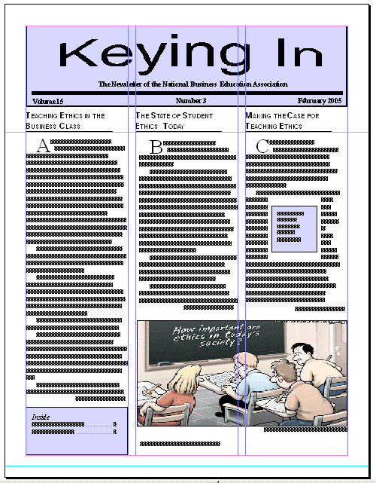
7 Assume this is the date or name of the organization and appears on every page—this is called the:
6 Label below picture:
5 Picture serves as the __________.
4 “Continued on pg 2”
2 Entire shaded panel:
10
9
8
3
Compliments of the New York Post
Directions:
Label the parts of the newsletter in the following table grid.
1 | 2
3 | 4
5 | 6
7 | 8
9 | 10

